Project Summary Report – Option C
Student: Gabriel Muñoz Luna
ID: 105967744
Project Title: Stock Price Prediction
Date: 02 November 2025
Tutor: Khoa Pham
Repo: https://github.com/Gabriel-M192/2025-HS2-COS30018-Intelligent-Systems-H1/tree/main/stock_prediction
Table of Contents
- Introduction
- Overall System Architecture
- Implemented Data Processing Techniques
- Experimented Machine Learning Techniques
- Extension Task (C7)
- Demonstration Scenarios and Results
- Critical Analysis of Implementation
- Summary and Conclusion
- Final changes
- References

- Introduction
This project, part of COS30018 – Intelligent Systems, focuses on developing a stock price prediction. The goal was to explore the potential of machine learning in forecasting financial time-series data. The project was implemented entirely in Python, following seven incremental tasks (C1–C7) that progressively covered environment setup, data processing, model design, advanced forecasting, and an optional research-based extension.
Throughout the semester, the code evolved from a basic single-file baseline into a modular and extensible system capable of handling multivariate and multistep forecasting, ensemble learning, and sentiment-based prediction.
- Overall System Architecture
The system is organized into clearly defined modules:
Data Loader (C2) – downloads and prepares historical stock data from Yahoo Finance (e.g., AMZN), handles missing values, scaling, and train/test splits.
Visualizer (C3) – generates time-series and candlestick charts for exploratory analysis.
Model Builder (C4–C5) – constructs and trains neural-network models (LSTM, GRU, RNN) for single-step and multistep forecasting.
Evaluator (C5–C6) – computes metrics such as RMSE, MAE, MAPE, R², and plots predicted vs actual values.
Extension Module (C7) – incorporates sentiment scores from financial news to improve classification of upward/downward movements.
- Implemented Data Processing Techniques (C2 & C3)
Loading & Caching: Implemented a reusable function that loads CSV data, fills NaNs, normalizes values using MinMaxScaler, splits data chronologically, and caches preprocessed arrays for future runs.
Feature Engineering: Used OHLCV ( Open, High, Low, Close, Volume ) features and derived daily deltas to improve temporal representation.
Train/Test Split: Supported both date-based and randomized splits.
Visualization: Added candlestick plots (mplfinance, plotly) and moving boxplots for pattern inspection and data quality checks.
File Structure: Data and scaler objects were saved as .npz and .pkl for consistent loading between tasks.
- Experimented Machine Learning Techniques (C4–C6)
- Model Architecture: Implemented flexible constructors for LSTM, GRU.
- Multi-Step Forecasting: Extended supervised learning to predict h steps ahead, supporting different lookback windows.
- Ensemble Methods: Combined predictions from multiple networks (LSTM + GRU) through averaging to improve stability.
- Evaluation Metrics: RMSE, MAE, MAPE, R² were computed for each experiment; results were plotted with confidence intervals using Monte Carlo Dropout.
- Model Saving: Implemented reproducible saving/loading of weights, scalers, and training logs.
- Extension Task
For the optional extension, a sentiment analysis pipeline was integrated using the Hugging Face Transformers library. Daily financial news headlines were collected and converted into sentiment scores (positive/negative/neutral).
- Demonstration Scenarios and Results
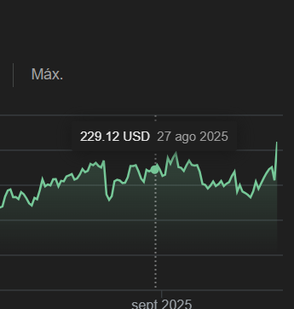
This image is the price of the day predicted
This is the predicted price for the next day
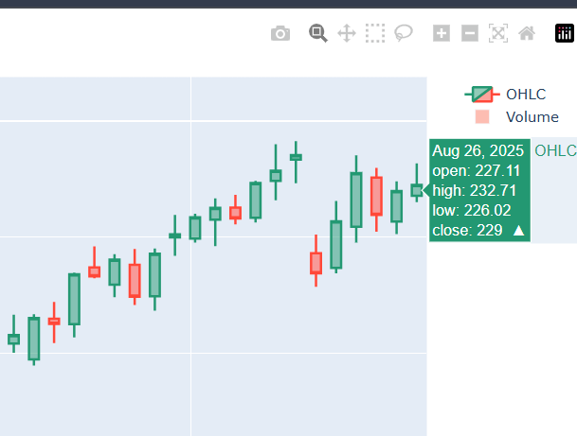
This image is the close of the day before the prediction
- Critical Analysis of Implementation
Strengths
- Modular design with clear pipeline structure
- Good use of data caching and scaling
- Integration of advanced techniques (MC-Dropout, Ensemble Learning)
- Comprehensive visualizations and evaluation
Limitations
- Limited data sources
- No real-time prediction
- Computational overhead on larger datasets
- Random sentiment
Future Improvements
- Add API for live data updates, user interface and real sentiment for the mood
- Implement cross-market transfer learning
- Summary and Conclusion
This project demonstrated the complete lifecycle of building an AI-based stock price forecasting system, from data collection to advanced modeling and evaluation.
Through the sequential Tasks C1–C7, the project evolved into a robust framework capable of handling complex temporal dependencies and incorporating external sentiment factors.
The results confirmed that deep learning models (LSTM/GRU) can capture market patterns reasonably well, while integrating sentiment data further enhances directional accuracy
- Final changes in the code
For the final version of the code, I change the form of the data lecture because in some parts the reading of the csv where hardcode with “Apple” only, so I make it functional with all the company name instead of Apple
- References
Yahoo Finance API Documentation.
COS30018 Lectures (2025).
Scikit-learn Documentation. (2024). Model Selection and Evaluation – Metrics and Cross-Validation. https://scikit-learn.org/stable/modules/classes.html
TensorFlow Documentation. (2025). Keras Loss Functions – Huber Loss and Callbacks. https://www.tensorflow.org/api_docs/python/tf/keras/losses/Huber
TensorFlow Documentation. (2025). Keras Recurrent Layers (LSTM, GRU, SimpleRNN, Bidirectional). https://www.tensorflow.org/api_docs/python/tf/keras/layers
Yahoo Finance API. (2024). Historical Market Data Retrieval using yfinance. https://pypi.org/project/yfinance/
Pandas Documentation. (2024). Time Series and Date/Time Functionality. https://pandas.pydata.org/docs/user_guide/timeseries.html
Idrees, H. (2024, July 5). RNN vs. LSTM vs. GRU: A Comprehensive Guide to Sequential Data Modeling. Medium. https://medium.com/@hassaanidrees7/rnn-vs-lstm-vs-gru-a-comprehensive-guide-to-sequential-data-modeling-03aab16647bb
TensorFlow Documentation (2025). Multi-Head Attention Layer. https://www.tensorflow.org/api_docs/python/tf/keras/layers/MultiHeadAttention
TensorFlow Documentation (2025). Keras Loss Functions – Huber Loss. https://www.tensorflow.org/api_docs/python/tf/keras/losses

